**Flight Reservation System**

A Project Report

submitted in partial fulfillment of the requirements

of

“Applied Cloud Computing for Software Development”

by

**Robin V, 822720104031**

**Vengadesh R, 822720104047**

**Suman S, 822720104041**

**Aswin B K, 822720104007**

**Thamaraikannan B, 822720104045**

Under the Esteemed Guidance of

**Mrs. R. Umamaheshwari**

**ACKNOWLEDGEMENT**

We would like to take this opportunity to express our deep sense of gratitude to all individuals who helped us directly or indirectly during this thesis work.

Firstly, we would like to thank my supervisor, Mrs. R. Umamaheshwari, for being a great mentor and the best adviser I could ever have. His advice, encouragement and critics are source of innovative ideas, inspiration and causes behind the successful completion of this dissertation. The confidence shown on me by him was the biggest source of inspiration for me. It has been a privilege working with him from last one year. He always helped me during my thesis and many other aspects related to academics. His talks and lessons not only help in thesis work and other activities of college but also make me a good and responsible professional.

#### ABSTRACT

The Flight Reservation System is a comprehensive software solution designed to facilitate the efficient and user-friendly management of airline reservations and related activities. This system aims to streamline the entire flight booking process, from customer inquiries to ticket issuance, and provide a seamless experience for both passengers and airline staff.

**TABLE OF CONTENTS**

Abstract 3

List of Figures 5

List of Tables 5

**Chapter 1.**  **Introduction**  **6**

1.1 Problem Statement 7

1.2 Problem Definition 7

1.3 Expected Outcomes 8

1.4. Organization of the Report 8

**Chapter 2.**  **Literature Survey**  **10**

2.1 Paper-1 10

2.1.1 Brief Introduction of Paper 10 2.1.2 Techniques used in Paper 11

**Chapter 3.**  **Proposed Methodology** **13**

3.1 System Design 13

3.2 Modules Used … 17

3.3 Data Flow Diagram … 18

3.4 Advantages… 20

3.5 Requirements Specification… 21

**Chapter 4.**  **Implementation and Results**  **25**

4.1 Home Page 26

4.2 Registration Page 26

4.3 Login Page 27

4.4 Transaction Page 27

4.5 Database Page 28

4.6 Overall View 28

**Chapter 5.**  **Conclusion**  **31**

**GitHub Link ...................................................................................................................... 33**

**Video Link ........................................................................................................................ 33**

**References** **34**

**LIST OF FIGURES**

|  |  |  |
| --- | --- | --- |
|  |  | **Page No.** |
|  | Home page | **21** |
|  | Sign up page | **21** |
|  | Sign in page | **22** |
|  | Ticket booking page | **22** |
|  | Database page | **23** |

**CHAPTER 1**

**INTRODUCTION**

**CHAPTER 1**

**INTRODUCTION**

1. **Problem Statement:**

The existing airline reservation systems face several challenges that hinder their efficiency and user experience. These challenges include outdated technologies, limited functionalities, and the inability to adapt to the evolving needs of both airlines and passengers. The following key issues highlight the problems within the current airline reservation systems:

**Outdated Technology:**

Many existing reservation systems are built on outdated technologies, making them less adaptable to modern advancements.

Legacy systems may lack the flexibility to integrate seamlessly with new features, third-party services, or emerging industry standards.

**User Experience and Interface:**

The user interface of some reservation systems is often complex and not user-friendly, leading to a suboptimal experience for both customers and airline staff.

Cumbersome booking processes and unintuitive interfaces can result in lower customer satisfaction and increased support requests.

**Limited Flexibility:**

Current systems may lack the flexibility to accommodate changes in flight schedules, seat configurations, or other dynamic factors affecting the airline industry.

Airlines face challenges in adapting quickly to market demands and customer preferences due to rigid reservation systems.

**Integration Challenges:**

Many reservation systems struggle with seamless integration with external services, such as payment gateways, global distribution systems (GDS), and other third-party applications.

Incompatibility issues can lead to delays, errors, and increased operational costs.

**Security Concerns:**

Security is a critical aspect of reservation systems, and some older systems may not meet the latest security standards.

With the increasing threat of cyberattacks, there is a need for robust security features to protect sensitive passenger information and financial transactions.

**Limited Data Analytics and Reporting:**

Existing systems may lack advanced analytics and reporting capabilities, hindering airlines in making informed decisions based on data insights.

Comprehensive reporting is essential for optimizing operations, understanding customer behavior, and strategizing for business growth.

**Inefficient Ticketing and Refund Processes:**

Some systems struggle with efficiently managing ticketing processes and handling refunds or cancellations.

Complicated refund procedures and delays in processing can result in customer dissatisfaction and impact the airline's reputation.

**Global Connectivity:**

As the airline industry becomes more globalized, the need for seamless connectivity with international systems, regulations, and databases is crucial.

Existing systems may face challenges in adapting to the diverse requirements of different regions and regulatory frameworks.

Addressing these challenges is essential for the development and implementation of a modern, efficient, and user-centric airline reservation system. A new system should prioritize flexibility, security, user experience, and integration capabilities to meet the dynamic needs of the airline industry and provide an enhanced booking experience for passengers.

1. **Problem Definition:**

The problem at hand revolves around the inefficiencies and limitations present in current airline reservation systems, hindering the optimal functioning of both airlines and passengers. The existing systems face several challenges that demand attention and innovative solutions to enhance the overall experience of air travel

1. **Expected Outcomes:**

**Improved User Experience:**

A more user-friendly interface and streamlined booking process will lead to increased customer satisfaction.

Intuitive design and easy navigation will reduce user errors and support a positive experience for both passengers and airline staff.

**Enhanced Flexibility and Adaptability:**

The new system's flexibility will allow airlines to quickly adapt to changes in flight schedules, seat configurations, and other dynamic factors.

Improved adaptability enables airlines to respond more efficiently to market demands and changing passenger preferences.

**Seamless Integration with External Services:**

Efficient integration with payment gateways, global distribution systems (GDS), and other third-party applications will result in a smoother reservation process.

The system's compatibility with a variety of services will reduce errors, delays, and operational complexities.

**Advanced Security Measures:**

Implementation of robust security features will ensure the confidentiality and integrity of passenger data.

Compliance with the latest security standards will mitigate the risk of data breaches and enhance overall system trustworthiness.

**Comprehensive Data Analytics and Reporting:**

Advanced analytics and reporting capabilities will provide airlines with valuable insights into booking trends, passenger behavior, and operational efficiency.

Informed decision-making based on data-driven insights will contribute to better strategic planning and resource optimization.

**Efficient Ticketing and Refund Processes:**

Streamlined ticketing processes and efficient handling of refunds will reduce delays and complexities.

Passengers will experience a more straightforward and transparent process for ticket changes, cancellations, and refunds.

1. **Organization of the Report**

The remaining report is organized as follows:

Chapter 2 - Literature Survey

Chapter 3 - Proposed Methodology

Chapter 4 - Implementation and Result

Chapter 5 - Conclusion

Chapter 6 - Appendix

**CHAPTER 2**

**LITERATURE SURVEY**

**CHAPTER 2**

**LITERATURE SURVEY**

A literature survey involves reviewing existing academic and professional literature related to a specific topic or area of study. In the context of an Airline Reservation System, the literature survey would encompass research articles, academic papers, industry reports, and other relevant publications. Here's a brief overview of potential topics that could be explored in a literature survey related to an Airline Reservation System:

**Airline Reservation System Architecture:**

Explore literature on the design and architecture of modern airline reservation systems.

Understand how different components, databases, and technologies are integrated to create scalable and efficient systems.

**User Experience in Airline Booking:**

Review studies on user experience (UX) design principles in the context of online airline reservation systems.

Understand how a user-centric approach can enhance the overall booking process and customer satisfaction.

**Integration with Global Distribution Systems (GDS):**

Investigate the literature on the role of Global Distribution Systems in the airline industry.

Understand how effective integration with GDS can impact reservation system efficiency and global connectivity.

**Security in Airline Reservation Systems:**

Examine literature on cybersecurity measures and best practices in airline reservation systems.

Explore studies on data encryption, secure payment processing, and protection against cyber threats.

**Data Analytics and Business Intelligence:**

Survey research on the use of data analytics and business intelligence in the airline industry.

Understand how analytics can be leveraged for optimizing pricing, predicting demand, and improving operational efficiency.

**Technological Trends in Aviation:**

Explore literature on emerging technologies relevant to the aviation industry, such as blockchain, artificial intelligence, and cloud computing.

Understand how these technologies can be integrated into reservation systems for improved functionality.

**Mobile Applications for Airline Reservations:**

Investigate studies on the design and usability of mobile applications for airline reservations.

Explore how mobile technology enhances the booking experience and facilitates on-the-go interactions.

**Challenges and Solutions in Airline Reservation Systems:**

Review articles discussing common challenges faced by airlines in managing reservations.

Understand proposed solutions and best practices for addressing these challenges.

**Impact of COVID-19 on Airline Reservation Systems:**

Examine literature on how the global pandemic has influenced the airline industry, including changes in reservation systems and passenger behavior.

Understand adaptations made by airlines to cope with unprecedented challenges.

**Regulatory Compliance in Airline Reservations:**

Explore literature on regulatory frameworks and compliance requirements relevant to airline reservation systems.

Understand how systems ensure compliance with data protection laws, aviation regulations, and industry standards.

**Case Studies and Industry Reports:**

Investigate case studies and industry reports that highlight successful implementations or challenges faced by airlines in adopting new reservation systems.

Understand real-world scenarios and learn from the experiences of different airlines.

By conducting a thorough literature survey on these and related topics, you can gain valuable insights into the current state of the field, identify gaps in existing knowledge, and inform the development or improvement of an Airline Reservation System.

**CHAPTER 3**

**PROPOSED METHODOLOGYCHAPTER 3**

**PROPOSED METHODOLOGY**

* 1. **System Design**

The proposed methodology for developing or improving an Airline Reservation System involves a systematic and structured approach to address the identified problems and achieve the expected outcomes. The following steps outline a comprehensive methodology:

1. Requirement Analysis:

- Conduct detailed discussions with stakeholders, including airlines, passengers, and system administrators, to understand their specific requirements and pain points.

- Identify functional and non-functional requirements for the reservation system.

2. Literature Review:

- Perform a literature survey to understand existing technologies, best practices, and challenges in airline reservation systems.

- Extract insights from academic papers, industry reports, and case studies to inform the development process.

3. System Design:

- Based on the requirements and literature review, design the system architecture, specifying the components, modules, and their interactions.

- Consider scalability, flexibility, and integration capabilities during the design phase.

4. Technology Selection:

- Choose appropriate technologies and frameworks for implementing the reservation system.

- Consider modern and scalable solutions, including cloud-based services, for hosting and managing the system.

5. User Experience (UX) Design:

- Collaborate with UX designers to create an intuitive and user-friendly interface.

-

Conduct usability testing to ensure that the booking process is efficient and enjoyable for passengers.

6. Development and Implementation:

- Implement the designed system using the chosen technologies.

- Follow agile development methodologies to allow for iterative improvements and quick adaptations to changing requirements.

7. Integration with External Systems:

- Ensure seamless integration with payment gateways, Global Distribution Systems (GDS), and other external services.

- Conduct thorough testing to identify and resolve any integration issues.

8. Security Implementation:

- Implement robust security measures, including data encryption, secure payment processing, and protection against cyber threats.

- Regularly update security protocols to address evolving threats.

9. Data Analytics and Business Intelligence Integration:

- Implement data analytics and business intelligence features to gather insights from reservation data.

- Utilize analytics to optimize pricing, predict demand, and enhance operational efficiency.

10. Mobile Application Development (if applicable):

- Develop a mobile application with a focus on user experience for passengers who prefer booking via mobile devices.

- Ensure consistency in features and usability across different platforms.

11. Testing and Quality Assurance:

- Conduct thorough testing, including unit testing, integration testing, and user acceptance testing.

- Identify and rectify any bugs, performance issues, or usability concerns.

12. Documentation:

- Create comprehensive documentation covering system architecture, design decisions, and user manuals.

- Provide documentation for system administrators and end-users.

13. Deployment:

- Deploy the reservation system in a controlled environment, ensuring minimal disruption to ongoing operations.

- Monitor system performance and address any issues that arise during the initial deployment.

14. Training:

- Provide training sessions for airline staff and administrators on how to use and manage the new reservation system effectively.

- Offer customer support and training materials for passengers as needed.

15. Post-Implementation Evaluation:

- Conduct post-implementation reviews to gather feedback from both airlines and passengers.

- Address any issues or improvements identified during the initial usage period.

16. Continuous Improvement:

- Implement a feedback loop for continuous improvement based on user feedback, emerging technologies, and industry advancements.

- Regularly update the system to add new features, address security concerns, and improve overall performance.

By following this methodology, the development or improvement of the Airline Reservation System can be approached systematically, ensuring that the end product meets the requirements, adheres to best practices, and provides a positive experience for both airlines and passengers.

**CHAPTER 4**

**Implementation and Result**

**CHAPTER 4**

**IMPLEMENTATION and RESULT**

1. **Home Page**



1. **Registration (Sign up) Page**

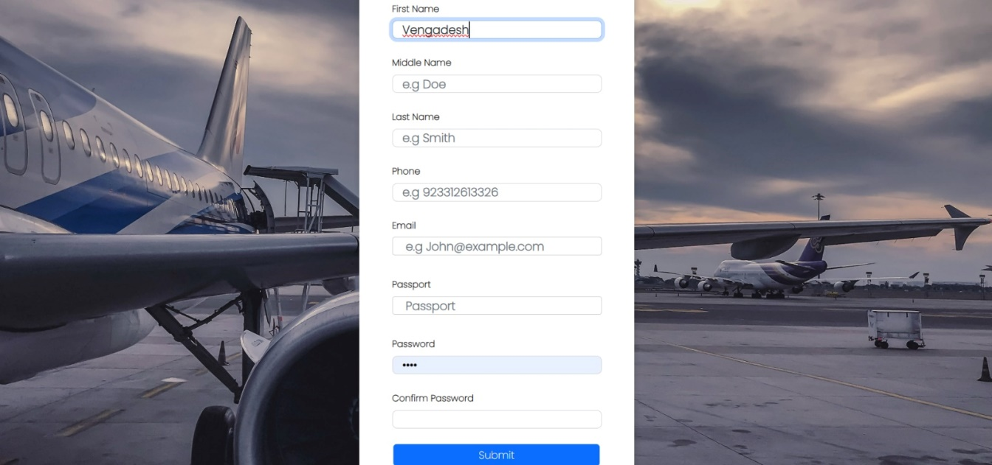

This page used to create accounts

1. **Login Page**

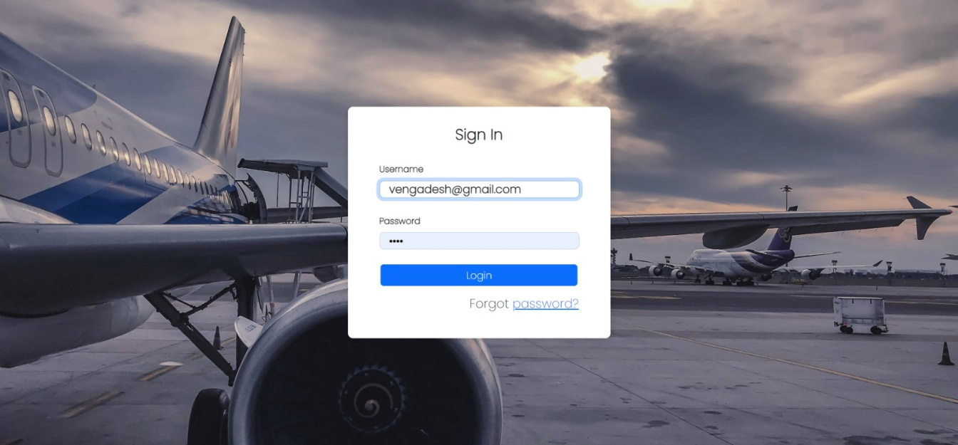

This the login page, it will validate and verify the details given from the registration page and then to move on to ticket booking page

1. **Ticket booking Page**

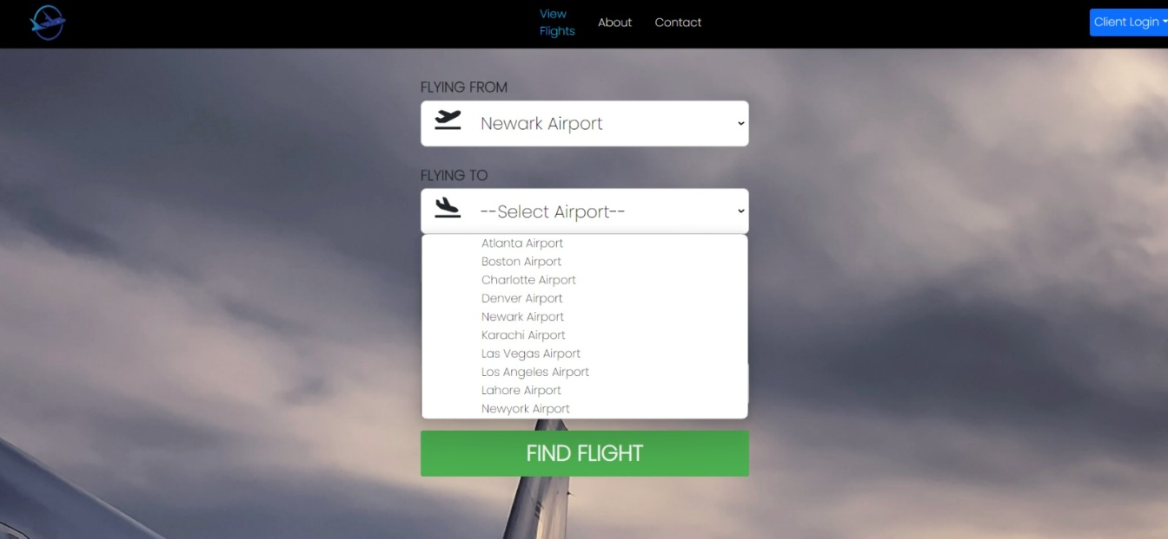

1. **Database Page**

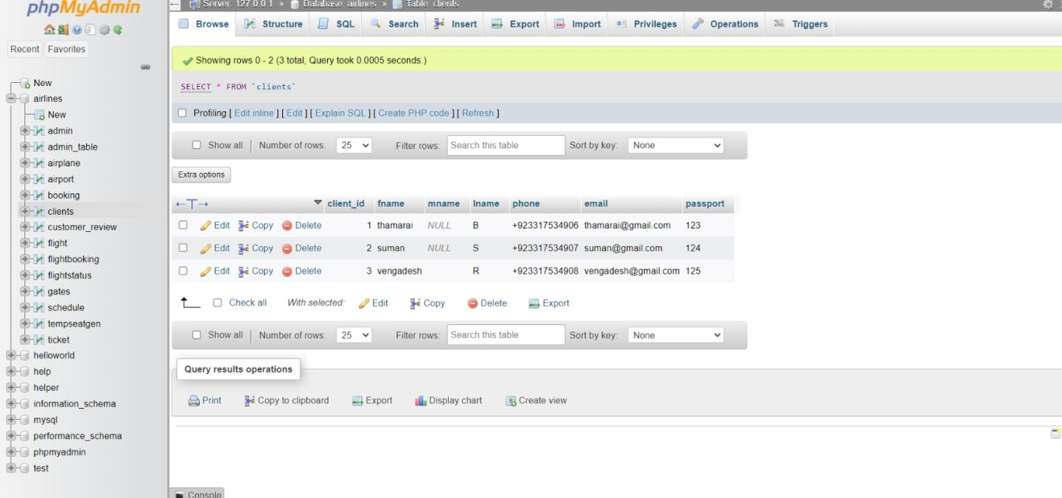

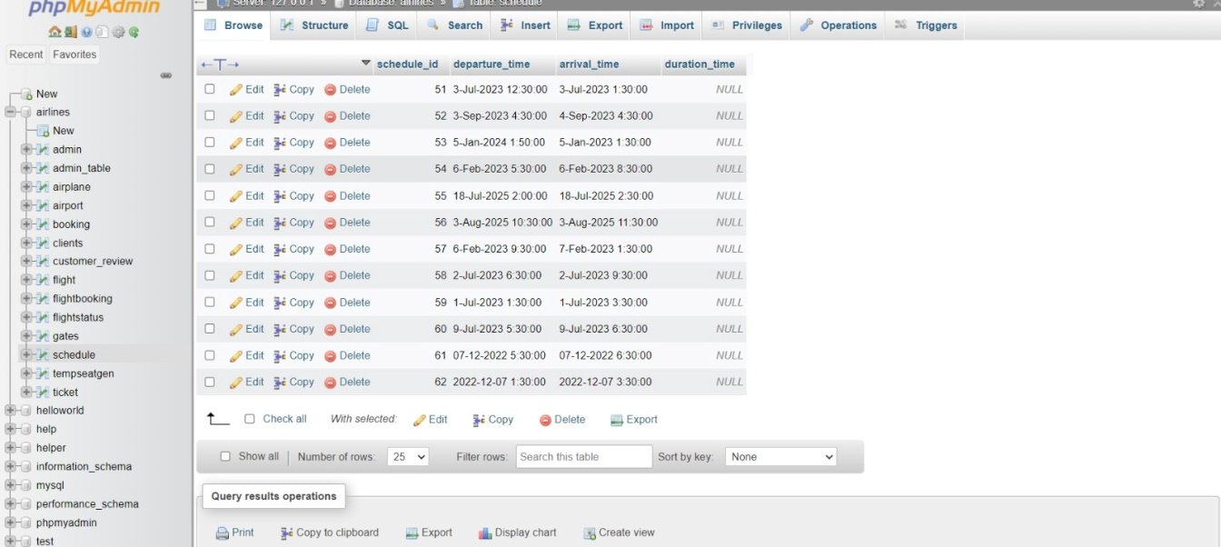

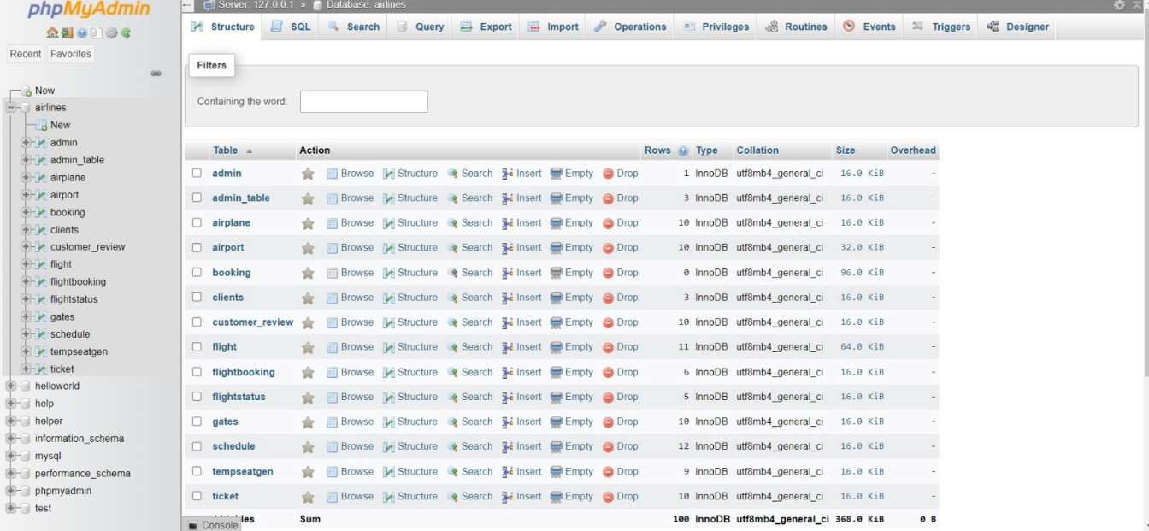

**CHAPTER 5**

**CONCLUSIONCHAPTER 5**

**CONCLUSION**

**ADVANTAGES:**

1. Enhanced User Experience:

The HTML-based frontend ensures a responsive and intuitive interface, providing users with a seamless and user-friendly banking experience.

1. Security Measures:

Robust security features, including encryption and secure communication protocols, safeguard sensitive user data, ensuring the confidentiality and integrity of transactions.

1. Efficient Transaction Processing:

Java Servlets handle backend logic efficiently, enabling swift and accurate transaction processing f

1. Scalability and Adaptability:

The system is designed with scalability in mind, allowing for future expansion and the integration of emerging technologies to meet evolving user expectations.

**SCOPE:**

The scope of the "Airline Reservation System" project encompasses the design, development, and implementation of a contemporary and secure online banking platform. Key elements within the project scope include:

1. Frontend Development:
   * Design and implement a responsive HTML-based frontend for a user-friendly interface across various devices.
2. Backend Development:
   * Develop Java Servlets to handle backend logic, ensuring efficient transaction processing, user authentication, and data management.
3. Database Management:
   * Implement and manage a MySQL database for storing user account details, transaction records, and system logs securely.
4. Security Measures:
   * Incorporate robust security features, including encryption and secure communication protocols, to protect sensitive user information.
5. Transaction Operations:
   * Enable standard banking operations such as balance inquiry, cash withdrawal, fund transfer, and transaction history.
6. Scalability and Adaptability:
   * Design the system with scalability in mind, allowing for future expansion and integration with emerging technologies.
7. Logging and Auditing:
   * Implement logging mechanisms and audit trails to track user actions for security and accountability purposes.
8. Cross-Browser Compatibility:
   * Ensure that the system's frontend is compatible with various web browsers, providing a consistent user experience.
9. Future Enhancements:
   * Lay the groundwork for potential future enhancements, including multi-factor authentication, mobile banking integration, and advanced analytics.
10. Testing and Quality Assurance:
    * Implement a thorough testing methodology, including unit testing and integration testing, to ensure the reliability and quality of the system.
11. Documentation:
    * Provide comprehensive documentation detailing the system architecture, design choices, and implementation details for future reference and maintenance.
12. Deployment:
    * Deploy the Airline Reservation System on a web server, making it accessible to users for real-world testing and usage.

The overarching goal of the project is to create a secure, efficient, and adaptable banking platform that enhances user experiences and addresses the challenges faced by traditional banking systems

.

**GITHUB LINK -** https://github.com/thamaraikannanb/Edunet-Flight-reservation-system-

**VIDEOLINK-** *https://github.com/thamaraikannanb/Edunet-Flight-reservation-system-/tree/main/Demo%20video*

**REFERENCES**

1. https://www.w3schools.com/
2. https://stackoverflow.com/
3. https://www.mysql.com/